**SQL Homework – 06 - Linux** Fani Shundovska

Linux for Software Testers – Homework

1. Log into terminal - username and password (Use sedcuser, not sedcuser1)

➢  After Login, go to the following filepath: **cd /home/sedcuser/Homework**

**1.**      Check the directory name in which you are now.

**2.**      Check the contents of your current directory

**Note: To display in multiple columns, it needs to be set to full screen!**

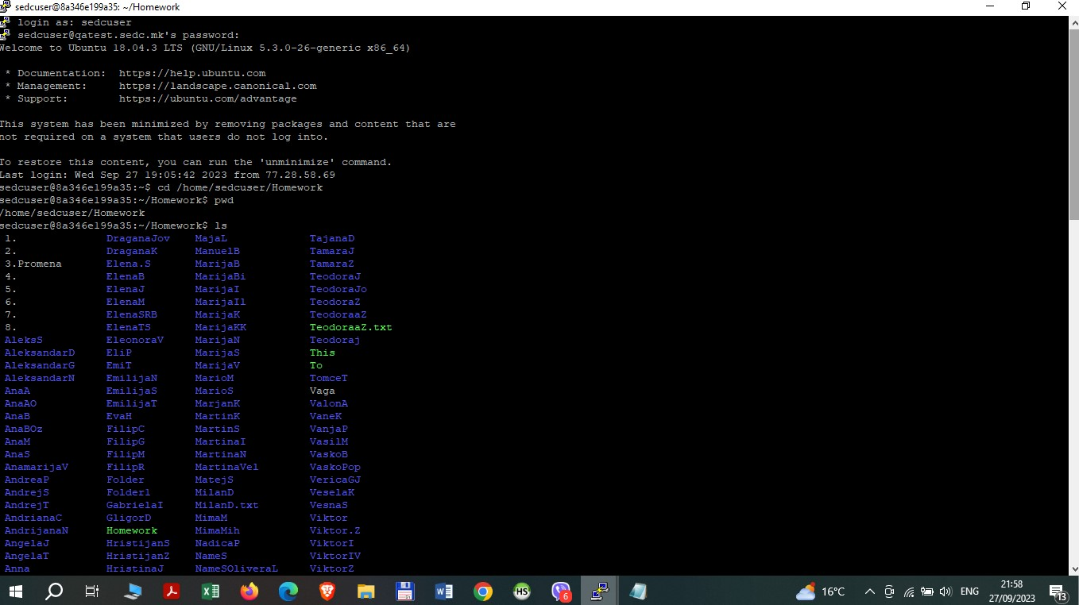

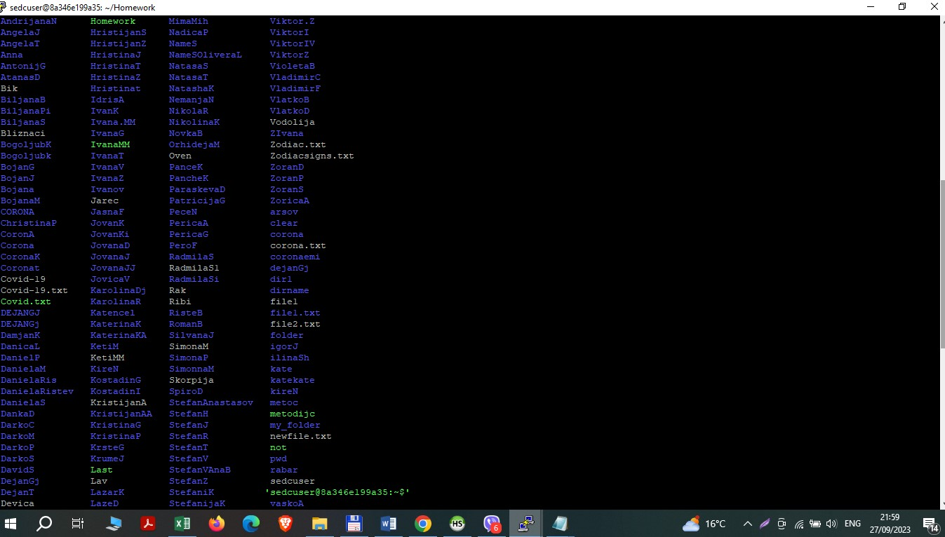

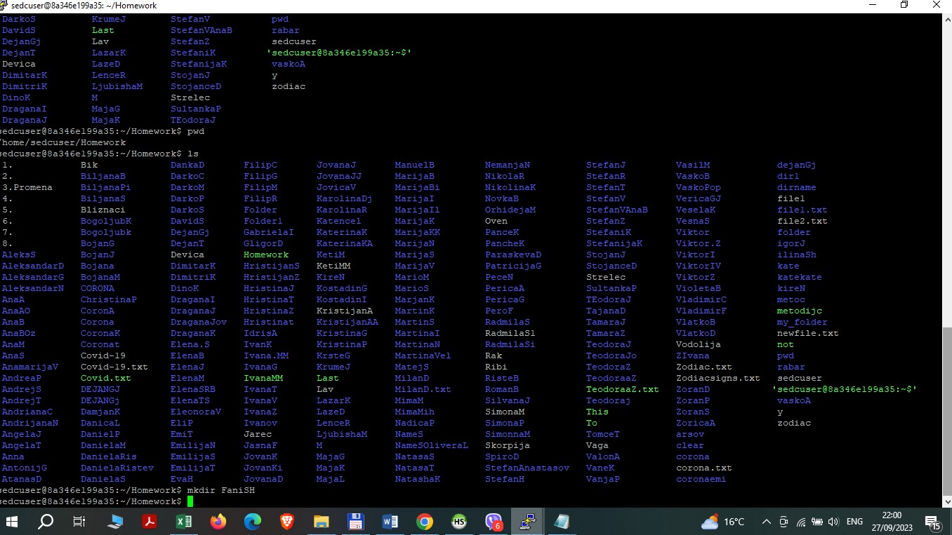

1. Create new directory **NameS** (name and the first letter of surname) in your current location.

•        **Create folder**

**1.**      Create two new text files **file1** and **file2** in the newly created directory, and populate them with the Zodiac signs (*file1*) and plans after Covid-19 (*file2*).* write at least 8 plans in *file2*

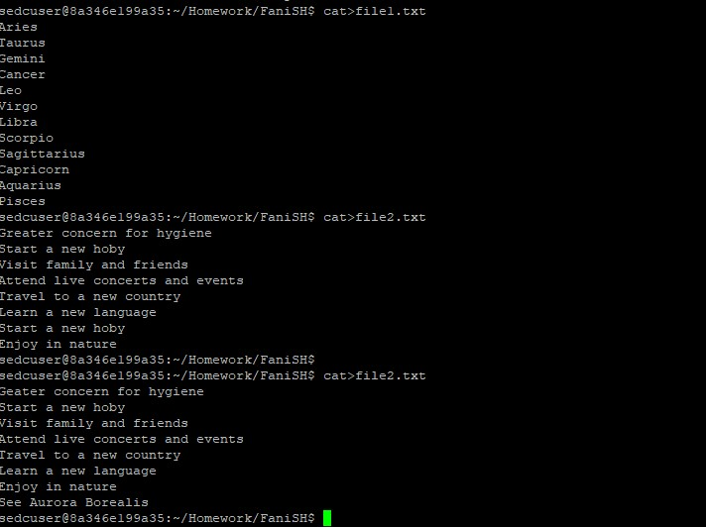

3. Now list both of the files for confirmation that all data is correctly added to them:

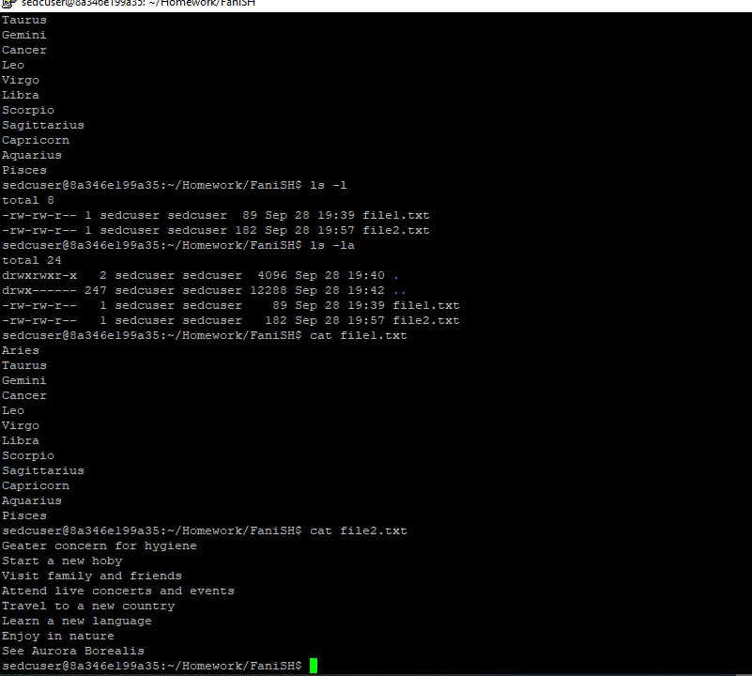

1. Rename the two files as follows: **1.**      *file1* -> zodiac **2.**      *file2* -> covid

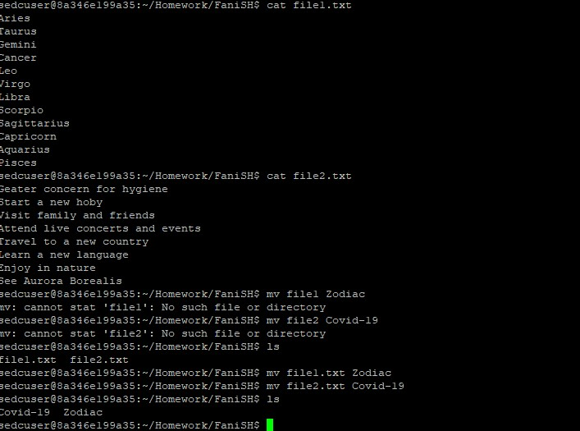

1. List fraction of data from both files:

**1.**      List the first 4 lines from file *zodiac*.

**2.**      Then list the last 6 lines from file covid.

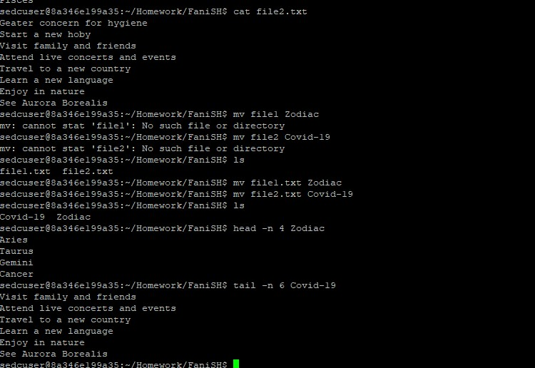

1. Create new directory **Corona** in the directory *NameS*.

•        **Create folder**

* 1. Move file *covid* to the new directory *corona*.

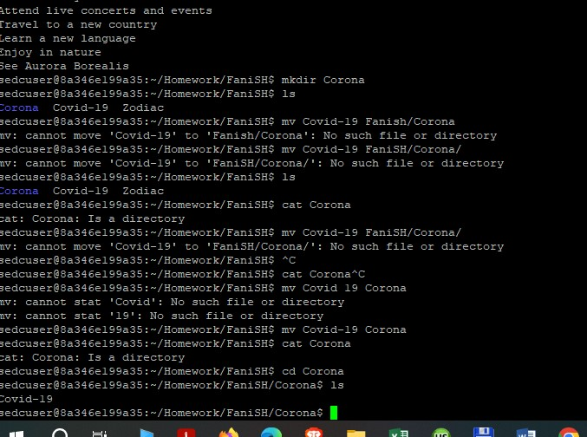

1. Next, remove the file *covid* from *corona* folder.

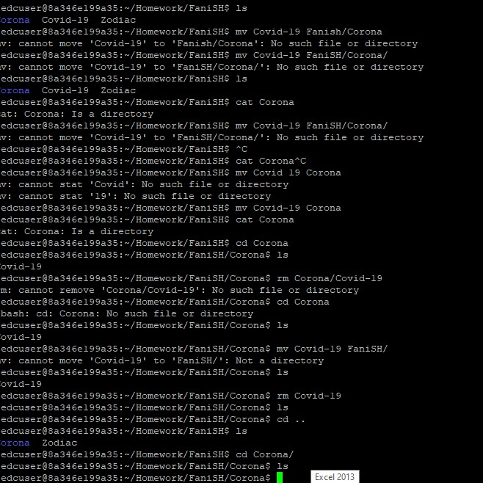

1. As last step, list all signs from *zodiac* file which has “us” in them.

